Spring Microservices 1

Limits Service
In the context of Spring Cloud and microservices architecture, a limits service is typically used to manage and enforce configurable limits or thresholds within a distributed application. This is a common pattern to ensure that different microservices adhere to certain constraints, such as rate limits, timeout durations, or any other operational limits.

Typical Use Case:
A limits service is often used in scenarios where multiple microservices need to adhere to the same set of configuration limits. Instead of hardcoding these limits within each service, they can be centralized and managed in a configuration server. This allows for easier updates and consistency across the application.

Key Components of a Limits Service
1. Configuration Properties:
- These are typically defined in external configuration files (like application.properties or application.yml) or in a centralized configuration server (like Spring Cloud Config).
2. Configuration Server:
- A Spring Cloud Config Server can serve as a centralized place to manage configuration properties. This server can pull configurations from a Git repository, file system, or other sources and serve them to client applications.
3. Client Service:
- Microservices that need to enforce limits can fetch these configurations at startup or refresh them at runtime from the configuration server.

Example Implementation
Here's an example of how you can implement a simple limits service using Spring Boot and Spring Cloud Config:

Step 1: Set Up the Configuration Server
1. Create a Spring Boot application for the configuration server:
<dependency>
<groupId>org.springframework.cloud</groupId>
<artifactId>spring-cloud-config-server</artifactId>
</dependency>
2. Enable Config Server:
@SpringBootApplication
@EnableConfigServer
public class ConfigServerApplication {
public static void main(String[] args) {
SpringApplication.run(ConfigServerApplication.class, args);
}
}
3. Configure the server to use a Git repository or local files:
# application.properties
spring.cloud.config.server.git.uri=https://github.com/your-repo/config-repo

Step 2: Define Configuration Properties
1. Create a configuration file in your Git repository (e.g., limits-service.yml):
limits-service:
minimum: 10
maximum: 1000

Step 3: Create the Limits Service
1. Create a Spring Boot application for the limits service:
<dependency>
<groupId>org.springframework.cloud</groupId>
<artifactId>spring-cloud-starter-config</artifactId>
</dependency>
2. Create a configuration class to map the properties:
@Configuration
@ConfigurationProperties(prefix = "limits-service")
public class LimitsConfiguration {
private int minimum;
private int maximum;
// getters and setters
}
3. Create a controller to expose the limits:
@RestController
public class LimitsController {
@Autowired
private LimitsConfiguration configuration;
@GetMapping("/limits")
public LimitsConfiguration retrieveLimits() {
return configuration;
}
}

Step 4: Configure the Limits Service to Use the Config Server
- Specify the configuration server URL in application.properties:
# application.properties
spring.config.import=optional:configserver:http://localhost:8888
Run the Config Server and Limits Service:
- Start the Config Server.
- Start the Limits Service

To fetch via spring-cloud-config-server
- Run both the servers simultaneously
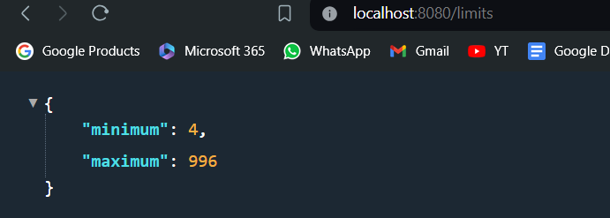
- Or else if you don't run both the server you will see that it fetches the default value:
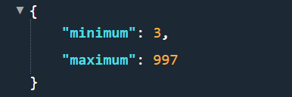

Conclusion
A limits service in a Spring Cloud environment allows you to manage and enforce application limits centrally. By using Spring Cloud Config, you can ensure that these configurations are consistent across multiple services and can be easily updated without changing the code. This approach enhances maintainability and scalability in a microservices architecture.

Spring Cloud Config Server
Spring Cloud Config Server provides a centralized configuration service that allows you to manage external properties for applications across all environments. This is particularly useful in a microservices architecture where multiple instances of applications require consistent and centralized configuration management.

Key Features of Spring Cloud Config Server
1. Centralized Configuration:
- Provides a single source of truth for configuration across distributed systems.
2. Environment-Specific Configurations:
- Supports different configurations for different environments (e.g., development, staging, production).
3. Version Control Integration:
- Integrates with Git, SVN, or local file system to manage configurations, providing version control and history.
4. Dynamic Refresh:
- Supports runtime refresh of configurations using Spring Cloud Bus, without needing to restart the applications.

How Spring Cloud Config Server Works
Spring Cloud Config Server retrieves configuration properties from a centralized source (like a Git repository) and exposes them via a REST API. Client applications can then fetch these properties from the Config Server at startup or during runtime.

Setting Up Spring Cloud Config Server

Step 1: Create a Spring Boot Application for Config Server
1. Add Dependencies:
- Add the spring-cloud-config-server dependency to your pom.xml:
<dependency>
<groupId>org.springframework.cloud</groupId>
<artifactId>spring-cloud-config-server</artifactId>
</dependency>
2. Enable Config Server:
- Annotate your main application class with @EnableConfigServer:
import org.springframework.boot.SpringApplication;
import org.springframework.boot.autoconfigure.SpringBootApplication;
import org.springframework.cloud.config.server.EnableConfigServer;
@SpringBootApplication
@EnableConfigServer
public class ConfigServerApplication {
public static void main(String[] args) {
SpringApplication.run(ConfigServerApplication.class, args);
}
}
3. Configure the Config Server:
- Set up the configuration properties in application.properties or application.yml to point to your configuration source (e.g., a Git repository):
# application.properties
spring.cloud.config.server.git.uri=file:///D:/NRV/Studies/Learn/Spring/Microservices/Spring-Microservices/git-localconfig-repo
spring.cloud.config.server.git.clone-on-start=true

Step 2: Create Configuration Files in Your Repository
1. Organize Configuration Files:
- Create configuration files in your Git repository. The file names should follow the convention <application-name>-<profile>.properties
Example: limits-service-dev.yml, limits-service-prod.yml
2. Define Configuration Properties:
- Define the configuration properties for different environments within these files.
# limits-service-dev.yml
limits-service:
minimum: 10
maximum: 1000

Step 3: Create a Spring Boot Application as Config Client
1. Add Dependencies:
- Add the spring-cloud-starter-config dependency to your client application's pom.xml:
<dependency>
<groupId>org.springframework.cloud</groupId>
<artifactId>spring-cloud-starter-config</artifactId>
</dependency>
2. Configure the Config Client:
- Set up the client application's application.properties to connect to the Config Server:
# application.properties
spring.application.name=limits-service
spring.cloud.config.uri=http://localhost:8888

3. Use the Configuration Properties:
- Use @ConfigurationProperties or @Value to inject the configuration properties from the Config Server into your client application.
@Configuration
@ConfigurationProperties(prefix = "limits-service")
public class LimitsConfiguration {
private int minimum;
private int maximum;
// getters and setters
}
/*-----------------------------------------------------------------------*/
@RestController
public class LimitsController {
@Autowired
private LimitsConfiguration configuration;
@GetMapping("/limits")
public LimitsConfiguration retrieveLimits() {
return configuration;
}
}

Advantages of Using Spring Cloud Config Server
1. Consistency:
- Ensures all microservices use the same configuration properties.
2. Ease of Management:
- Centralizes the management of configuration properties, making it easier to update and maintain.
3. Environment-Specific Configurations:
- Allows for easy management of different configurations for different environments (e.g., dev, test, prod).
4. Security:
- Securely manages sensitive configuration data (e.g., credentials) using Spring Cloud Config's support for encryption and decryption.
5. Scalability:
- Helps in scaling microservices by providing a centralized configuration management system.

Once you run the spring-cloud-config-server
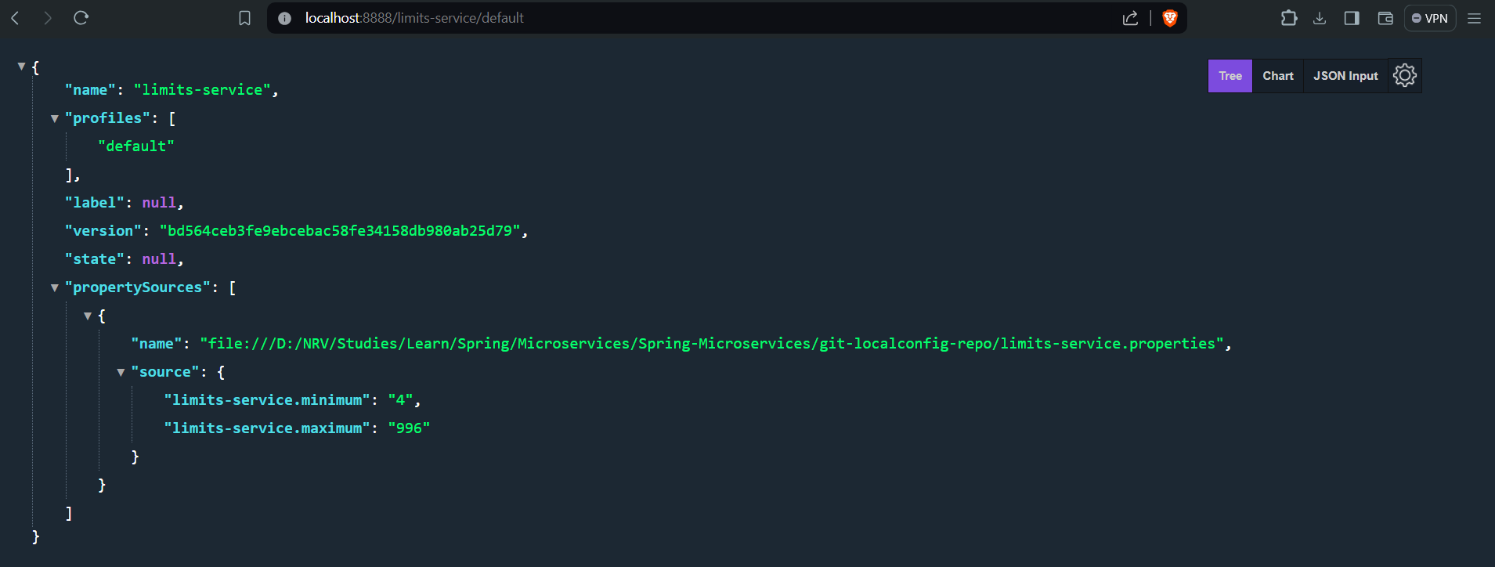
This will show that it has been connected with your local git config repo and is able to fetch the value.

Conclusion
Spring Cloud Config Server is a powerful tool for managing configuration properties in a microservices architecture. It provides a centralized, version-controlled, and environment-specific way to manage application configurations, enhancing consistency, security, and ease of management across distributed systems.

Currency Conversion Microservice

Currency-Exchange-Service

Dependencies:
- Web
- DevTools
- Actuator
- Config Client
- Spring data JPA
- H2 db
application.properties:
spring.config.import=optional:configserver:http://localhost:8888
spring.application.name=Currency-Exchange
server.port=8000
spring.jpa.show-sql=true
spring.datasource.url=jdbc:h2:mem:testdb
spring.h2.console.enabled=true
spring.application.name=currency-exchange
server.port=8000
spring.jpa.defer-datasource-initialization=true
src/main/resources/data.sql:
insert into currency_exchange
(id,currency_from,currency_to,conversion_multiple,environment)
values(10001,'USD','INR',65,'');
insert into currency_exchange
(id,currency_from,currency_to,conversion_multiple,environment)
values(10002,'EUR','INR',75,'');
insert into currency_exchange
(id,currency_from,currency_to,conversion_multiple,environment)
values(10003,'AUD','INR',25,'');
CurrencyExchange Model:
@Entity
public class CurrencyExchange {
@Id
private Long id;
@Column(name = "currency_from")
private String from;
@Column(name = "currency_to")
private String to;
private BigDecimal conversionMultiple;
private String environment;
//Getters and Setters
Repo:
public interface CurrencyExchangeRepo extends JpaRepository<CurrencyExchange, Long> {
CurrencyExchange findByFromAndTo(String from, String to);
}
Controller:
@RestController
public class CurrencyExchangeController {
@Autowired
CurrencyExchangeRepo exchangeRepo;
@Autowired
private Environment environment;
@GetMapping("/currency-exchange/from/{from}/to/{to}")
public CurrencyExchange retrieveExchange(
@PathVariable String from,
@PathVariable String to
) {
CurrencyExchange currencyExchange = exchangeRepo.findByFromAndTo(from, to);
if (currencyExchange == null) {
throw new RuntimeException("Data not available");
}
String port = environment.getProperty("local.server.port");
currencyExchange.setEnvironment(port);
return currencyExchange;
}
}

Currency Conversion Microservice
Dependencies
- Web
- DevTools
- Actuator
- Config Client
application.properties:
spring.application.name=Currency-Conversion
server.port=8100
spring.config.import=optional:configserver:http://localhost:8888
CurrencyConversion model
public class CurrencyConversion {
private Long id;
private String from;
private String to;
private BigDecimal quantity;
private BigDecimal conversionMultiple;
private BigDecimal totalCalculatedAmount;
private String environment;
// Getters, Setters, All/No Args Contr
}
Keeping the structure of CurrencyConversion similar to the CurrencyExchange so that we can fetch the data form the CurrencyExchange using a Proxy (Feign).
Controller method using RestTemplate (Old method):
@GetMapping("/currency-conversion/from/{from}/to/{to}/quantity/{quantity}")
public CurrencyConversion calculateCurrencyConversion(
@PathVariable String from,
@PathVariable String to,
@PathVariable BigDecimal quantity
) {
HashMap<String, String> uriVariables = new HashMap<>();
uriVariables.put("from", from);
uriVariables.put("to", to);
ResponseEntity<CurrencyConversion> responseEntity = new RestTemplate() .getForEntity("http://localhost:8000/currency-exchange/from/{from}/to/{to}",
CurrencyConversion.class, uriVariables);
CurrencyConversion currencyConversion = responseEntity.getBody();
return new CurrencyConversion(currencyConversion.getId(),
from, to, quantity,
currencyConversion.getConversionMultiple(),
quantity.multiply(currencyConversion.getConversionMultiple()),
currencyConversion.getEnvironment()+" Rest Template");
}
- This code defines a Spring REST API endpoint for currency conversion.
- It captures source and target currency codes, and amount to convert from the URL path.
- It builds a map to store these captured values.
- It uses RestTemplate to call another service (likely a currency exchange service) to get the conversion rate.
- It calculates the converted amount based on the retrieved rate and the requested amount.
- It builds a new response object with the converted amount and additional information.
- Error handling and security are aspects not covered in this code but might be important to consider in a real-world application.

Feign
Feign is a declarative web service client provided by Spring Cloud that simplifies making HTTP requests to other microservices. With Feign, you can create a proxy to interact with other services by defining an interface and annotating it. This makes calling other microservices as simple as calling a method.

Step-by-Step Guide
Step 1: Add Dependencies
<dependency>
<groupId>org.springframework.cloud</groupId>
<artifactId>spring-cloud-starter-openfeign</artifactId>
</dependency>

Step 2: Enable Feign Clients
Enable Feign clients in your Spring Boot application by annotating your main application class with @EnableFeignClients.
@SpringBootApplication
@EnableFeignClients
public class CurrencyConversionServiceApplication {
public static void main(String[] args) {
SpringApplication.run(CurrencyConversionServiceApplication.class, args);
}
}

Step 3: Define a Feign Client Interface(Proxy)
Create an interface that will serve as a proxy to the other microservice. Use the @FeignClient annotation to specify the name of the service and the base URL.
@FeignClient(name = "currency-exchange", url = "localhost:8000")
public interface CurrencyExchangeProxy {
@GetMapping("/currency-exchange/from/{from}/to/{to}")
public CurrencyConversion retrieveExchange(
@PathVariable String from,
@PathVariable String to
);
}

Step 4: Autowire proxy to controller to fetch data from other microservice
@Autowired
CurrencyExchangeProxy proxy;
@GetMapping("/currency-conversion-feign/from/{from}/to/{to}/quantity/{quantity}")
public CurrencyConversion calculateCurrencyConversionFeign(
@PathVariable String from,
@PathVariable String to,
@PathVariable BigDecimal quantity
) {
CurrencyConversion currencyConversion = proxy.retrieveExchange(from, to);
return new CurrencyConversion(currencyConversion.getId(),
from, to, quantity,
currencyConversion.getConversionMultiple(),
quantity.multiply(currencyConversion.getConversionMultiple()),
currencyConversion.getEnvironment());
}

Naming Server - Netflix Eureka
Dependencies
- Eureka Server
- DevTools
- Actuator
application.properties:
spring.application.name=Naming-Server
server.port=8761
eureka.client.register-with-eureka=false
eureka.client.fetch-registry=false

Netflix Eureka
Eureka is a service discovery tool from the Netflix OSS suite that is commonly used with Spring Cloud. In a microservices architecture, it helps manage service instances and their locations. This is especially useful when services need to dynamically scale up or down and their IP addresses and ports change frequently.
Key Components:
- Eureka Server: This is the service registry where microservices register themselves and discover other services. (naming-server)
- Eureka Client: This is the microservice that registers itself with the Eureka server and also fetches the registry information to find other services. (Currency-Exchange and Currency-Conversion microservice)

Connect Currency Conversion Microservice & Currency Exchange Microservice to Eureka
Add following Dependency in both the:
<dependency>
<groupId>org.springframework.cloud</groupId>
<artifactId>spring-cloud-starter-netflix-eureka-client</artifactId>
</dependency>
Add following line in application.properties:
eureka.client.serviceUrl.defaultZone=http://localhost:8761/eureka
Now run Eureka application and then run both microservices:
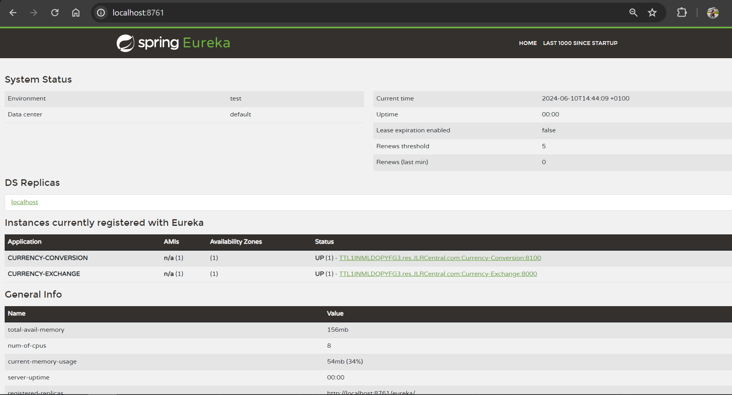
You’ll see an Interface like this on the localhost port in which you are running Eureka Application.

Spring Cloud API Gateway
Dependencies:
- DevTools
- Actuator
- Config Client
- Eureka Discovery Client
- Reactive Gateway (Spring Cloud Routing)
spring.application.name=Api-Gateway
server.port=8765
eureka.client.serviceUrl.defaultZone=http://localhost:8761/eureka
#spring.cloud.gateway.discovery.locator.enabled=true
#spring.cloud.gateway.discovery.locator.lower-case-service-id=true
spring.cloud.gateway.discovery.locator.enabled=true
The property spring.cloud.gateway.discovery.locator.enabled=true is used in Spring Cloud Gateway to enable service discovery functionality. Here's why it's important:
- Dynamic Routing: By enabling discovery locator, Spring Cloud Gateway can dynamically discover microservices registered with a service registry like Eureka. This eliminates the need to hardcode service URLs in your gateway routes.
- Flexibility: You can define routes based on service names instead of specific URLs. This makes your gateway configuration more flexible and adaptable to changes in your microservices architecture.
- Load Balancing: Service discovery allows the gateway to load balance requests across multiple instances of a microservice for improved scalability and fault tolerance.
You can access the microservices via eureka client name + microservice controller uri
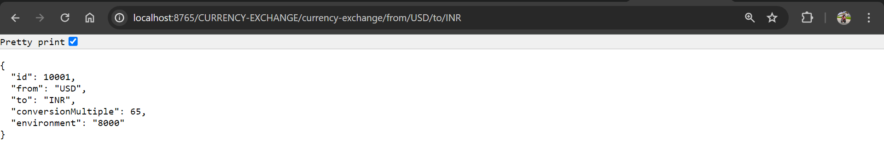
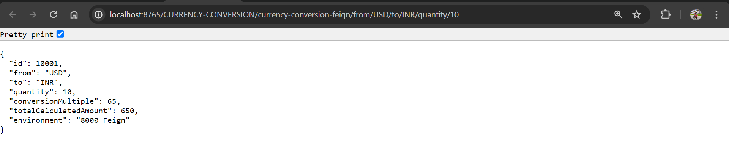

Core Functionality:
- Acts as a single entry point for all API requests coming from client applications.
- Routes incoming requests to the appropriate microservices based on various criteria like path, headers, or method.
- Provides functionalities like:
  - Security: Authentication and authorization checks to protect APIs.
  - Load Balancing: Distributes requests across multiple instances of a microservice for scalability.
  - Rate Limiting: Controls the number of requests an API can receive to prevent overloading.
  - Monitoring: Provides insights into API traffic and gateway health.

Benefits of using Spring Cloud API Gateway:
- Simplified API Management: Centralizes API routing and management, reducing complexity in individual microservices.
- Improved Developer Experience: Developers can focus on building microservice functionalities without worrying about complex routing logic.
- Enhanced Scalability and Fault Tolerance: Load balancing and fault tolerance features make the API gateway resilient to service outages.
- Increased Security: Centralized security checks at the gateway layer improve overall API security.

Spring Cloud API Gateway and Netflix Eureka
Netflix Eureka and Spring Cloud API Gateway work together seamlessly in a microservices architecture to provide a dynamic and scalable way to manage API traffic. Here's how they collaborate:

Eureka (Service Registry):
1. Acts as a central server where microservices register themselves upon startup.
2. Stores information about each registered microservice, including:
- ID
- Location (URL)
- Health status
- Metadata

Spring Cloud API Gateway:
1. Acts as a single entry point for all API requests coming from client applications.
2. Routes incoming requests to the appropriate microservices based on various criteria.

Interaction for Routing:
1. Client Request: A client application sends a request to the API Gateway at its designated URL (e.g., http://localhost:8765/products).
2. Route Matching (with Service Discovery):
- Enabled Service Discovery: If service discovery with Eureka is enabled in the API Gateway configuration:
  - The API Gateway might consult Eureka to find the microservice ID associated with the requested path (e.g., /products might map to the product-service ID).
  - It retrieves the location (URL) of a healthy instance of the microservice from Eureka.
- Pre-configured Routes: Alternatively, the API Gateway might use pre-configured routes that directly point to specific microservices without relying on Eureka.
3. Forwarding Request: The API Gateway forwards the received request (including headers, body, etc.) to the identified microservice instance.
Benefits of using them together:
- Dynamic Routing: Service discovery allows the gateway to discover new microservices or changes in location automatically, without updating routes manually.
- Improved Scalability: Eureka helps locate healthy instances of microservices for load balancing and fault tolerance.
- Decoupled Services: Microservices don't need to know each other's location directly, promoting loose coupling and easier maintenance.

Here's an analogy:
Imagine Eureka as a phone book for your microservices, storing their contact information (URLs). The API Gateway acts like a smart receptionist who consults the phone book (Eureka) to find the right microservice to connect the client (API request) to.
Now accessing a microservice with such long url isn’t good:
http://localhost:8765/CURRENCY-EXCHANGE/currency-exchange/from/USD/to/INR
http://localhost:8765/CURRENCY-CONVERSION/currency-conversion/from/USD/to/INR/quantity/10
http://localhost:8765/CURRENCY-CONVERSION/currency-conversion-feign/from/USD/to/INR/quantity/10

So we can create a ApiGatewayConfiguration to add routing:
@Configuration
public class ApiGatewayConfiguration {
@Bean
public RouteLocator gatewayRouter(RouteLocatorBuilder builder) {
return builder.routes()
.route(p -> p.path("/currency-exchange/**")
.uri("lb://currency-exchange"))
.route(p -> p.path("/currency-conversion/**")
.uri("lb://currency-conversion"))
.route(p -> p.path("/currency-conversion-feign/**")
.uri("lb://currency-conversion"))
.route(p -> p.path("/currency-conversion-new/**")
//Rerouting to currency-conversion-feign
.filters(f -> f.rewritePath(
"/currency-conversion-new/(?<segment>.*)",
"/currency-conversion-feign/${segment}"))
.uri("lb://currency-conversion"))
.build();
}
}
With these custom routes our routes will look this this:
http://localhost:8765/currency-exchange/from/USD/to/INR
http://localhost:8765/currency-conversion/from/USD/to/INR/quantity/10
http://localhost:8765/currency-conversion-feign/from/USD/to/INR/quantity/10
http://localhost:8765/currency-conversion-new/from/USD/to/INR/quantity/10

Logging filter to show the request coming in API Gateway (could be used for AUTH):
@Component
public class LoggingFilter implements GlobalFilter {
private Logger logger = LoggerFactory.getLogger(LoggingFilter.class);
@Override
public Mono<Void> filter(ServerWebExchange exchange,
GatewayFilterChain chain) {
logger.info("Path of the request received -> {}",
exchange.getRequest().getPath());
return chain.filter(exchange);
}
}

Circuit Breaker using Resilience4J
The Circuit Breaker pattern is a powerful technique used to enhance the fault tolerance and resilience of microservices architectures. It acts as a protective mechanism that shields your applications from cascading failures. Let's delve into its functionality and how Resilience4j integrates it in Spring Boot:
Circuit Breaker Pattern:
Imagine a circuit breaker like a physical circuit with a fuse. Here's how it works:
- Closed State: Initially, the circuit is closed, allowing service requests to flow freely to a target service ( microservice).
- Open State: If a service experiences a high number of failures within a defined timeframe (e.g., consecutive timeouts or exceptions), the circuit trips and enters an open state. In this state, subsequent requests are no longer forwarded to the potentially failing service.
- Half-Open State: After a set period (e.g., a few seconds), the circuit enters a half-open state. A single request is allowed through to test if the service has recovered.
  - If the request succeeds, the circuit resets to the closed state, and normal operation resumes.
  - If the request fails again, the circuit remains open for a longer duration before another half-open attempt.
Benefits of Circuit Breaker:
- Improved System Stability: Isolates failing services, preventing them from overloading and causing cascading failures in other parts of the system.
- Enhanced Fault Tolerance: Makes the overall system more resilient to failures by gracefully handling service outages.
- Reduced Load: Protects backend services from unnecessary requests during outages, allowing them to focus on recovery.

Resilience4j in Spring Boot
Resilience4j is a popular Java library that provides a comprehensive suite of fault tolerance patterns, including Circuit Breaker. Spring Boot integrates seamlessly with Resilience4j, allowing you to easily implement the Circuit Breaker pattern in your applications.
Add following dependencies in currency-exchange pom.xml
<dependency>
<groupId>org.springframework.boot</groupId>
<artifactId>spring-boot-starter-aop</artifactId>
</dependency>
<dependency>
<groupId>io.github.resilience4j</groupId>
<artifactId>resilience4j-spring-boot2</artifactId>
</dependency>
CircuitBreakerController:
@RestController
public class CircuitBreakerController {
private Logger logger = LoggerFactory.getLogger(CircuitBreakerController.class);
@GetMapping("/sample-api")
//@Retry(name = "sample-api", fallbackMethod = "hardcodedResponse")
//@CircuitBreaker(name = "default", fallbackMethod = "hardcodedResponse")
//@RateLimiter(name="default")
@Bulkhead(name = "sample-api")
public String sampleApi() {
logger.info("Sample api call received");
/*ResponseEntity<String> forEntity = new RestTemplate().getForEntity("http://localhost:8080/some-dummy-url",
String.class);
return forEntity.getBody();*/
return "sample-api";
}
public String hardcodedResponse(Exception ex) {
return "fallback-response";
}
}
application.properties:
resilience4j.retry.instances.sample-api.maxAttempts=5 #NEW
resilience4j.retry.instances.sample-api.waitDuration=1s
resilience4j.retry.instances.sample-api.enableExponentialBackoff=true
#resilience4j.circuitbreaker.instances.default.failureRateThreshold=90
resilience4j.ratelimiter.instances.default.limitForPeriod=2
resilience4j.ratelimiter.instances.default.limitRefreshPeriod=10s
resilience4j.bulkhead.instances.default.maxConcurrentCalls=10
resilience4j.bulkhead.instances.sample-api.maxConcurrentCalls=10
This code snippet showcases a Spring Boot controller with a sampleApi endpoint and utilizes Resilience4j for fault tolerance mechanisms. Let's break down the controller, properties, and how they work together:
Controller (CircuitBreakerController):
- @RestController: Indicates this class is a REST controller that can handle incoming HTTP requests.
- private Logger logger = LoggerFactory.getLogger(CircuitBreakerController.class);: Creates a logger instance for logging messages.
- @GetMapping("/sample-api"): Defines a GET HTTP request handler for the /sample-api endpoint.
Commented Out Fault Tolerance Annotations:
- These annotations (@Retry, @CircuitBreaker, @RateLimiter) are commented out but provide examples of different Resilience4j functionalities.
- We'll discuss them for completeness.
Active Fault Tolerance Annotation:
- @Bulkhead(name = "sample-api"): This annotation enables the Bulkhead pattern for the sampleApi endpoint.
  - It restricts the number of concurrent calls allowed to execute the sampleApi method.
sampleApi Method:
- logger.info("Sample api call received");: Logs a message indicating an API call was received.
- The commented-out section demonstrates how to call another service using RestTemplate.
- Currently, the method simply returns the string "sample-api".
hardcodedResponse Method:
- This method acts as a fallback mechanism for all the commented-out fault tolerance annotations.
- It takes an Exception argument and returns a string "fallback-response".
- This response will be returned if the underlying service call fails or exceeds the limits set by the annotations.
Properties:
These properties configure specific Resilience4j instances for the sample-api endpoint:
- resilience4j.retry.instances.sample-api.*: These properties (commented out) would configure a Retry instance for sampleApi.
  - maxAttempts=5: Sets the maximum number of retries allowed before giving up (default: 3).
  - waitDuration=1s: Defines the waiting time between retries (default: 100ms).
  - enableExponentialBackoff=true: Enables exponential backoff for increasing wait times between retries.
- resilience4j.circuitbreaker.instances.default.failureRateThreshold=90 (commented out): This property would configure a CircuitBreaker instance (default name is "default"). It sets the failure rate threshold (percentage of failed calls) to trigger the open state (default: 50).
- resilience4j.ratelimiter.instances.default.limitForPeriod=2 (commented out): This property would configure a RateLimiter instance (default name is "default"). It sets the maximum allowed calls within the specified period (default: 10).
- resilience4j.ratelimiter.instances.default.limitRefreshPeriod=10s (commented out): Defines the time window for the rate limit (default: 1s).
- resilience4j.bulkhead.instances.default.maxConcurrentCalls=10: This property sets the default maximum concurrent calls allowed for any Bulkhead instance without a specific name (default: 10).
- resilience4j.bulkhead.instances.sample-api.maxConcurrentCalls=10: This property overrides the default for the sampleApi endpoint, also setting the maximum concurrent calls to 10.
Key Points:
- By commenting out the annotations, this code demonstrates potential configurations for different fault tolerance mechanisms.
- The active @Bulkhead annotation limits concurrent calls to the sampleApi method, preventing overloading and improving overall system stability.
- The hardcodedResponse method provides a fallback response in case of failures.

@Retry,@CircuitBreaker,@RateLimiter
1. @Retry:
- Functionality: This annotation enables retry logic for methods or service calls. If a method call fails due to a specific exception, it will be retried a configured number of times before throwing an exception.
- Benefits:
  - Helps handle transient failures like network issues or timeouts by attempting the operation again automatically.
  - Reduces the risk of cascading failures by allowing the service to recover from temporary hiccups.
- Configuration: You can specify the number of retries, wait time between retries, and the types of exceptions to retry on.
2. @CircuitBreaker:
- Functionality: The Circuit Breaker pattern protects your application from cascading failures caused by a continuously failing service. It acts like a switch that:
  - Starts in a closed state, allowing calls to the target service.
  - Trips to an open state if failures exceed a threshold within a timeframe, preventing further calls and implementing a fallback strategy.
  - Transitions to a half-open state after a period, allowing a single attempt to check if the service has recovered. The circuit resets to closed if successful, or remains open for a longer duration before another half-open attempt.
- Benefits:
  - Isolates failing services, preventing them from overloading and causing system instability.
  - Enhances fault tolerance by gracefully degrading functionality during outages.
  - Reduces load on failing services, allowing them to focus on recovery.
- Configuration: You can define the failure threshold, timeout duration, and half-open state time.
3. @RateLimiter:
- Functionality: This annotation implements rate limiting to control the number of requests a service can receive within a specific time window. It helps prevent overloading and ensures fair resource allocation among clients.
- Benefits:
  - Prevents denial-of-service attacks by throttling excessive requests.
  - Protects backend services from being overwhelmed by sudden traffic spikes.
  - Enforces fair access to resources for all clients.
- Configuration: You can define the rate limit (requests per time window) and the strategy for handling exceeding the limit (e.g., throwing an exception or queuing requests).

